**Front End Web Development**

* HTML
* CSS
* Bootstrap
* JavaScript
* jQuery
* Angular

**Setup Environment for Working with Web Application:**

* Download and install “Node.js” on your PC
  + Node.js will provide a “Package Manager” tool “NPM [Node Package Manager]”
  + Package Manager is a software tool used by web developers to download and install various libraries required for project.
  + There are various package manager tools like
    - **NPM**
    - Yarn
    - Bower
    - Grunt
    - Growl
    - NuGet
    - RubyGems etc..
  + Download **Node.js 14x version** for NPM  
    [**https://nodejs.org/en/download/**](https://nodejs.org/en/download/)
  + Install on your PC
  + Open Command Prompt [Run – cmd]  
    C:\> node -v  
    C:\> npm -v

**Download and install “Visual Studio Code” editor**

* Editor is a software tool, which is used by developers for
  + Building
  + Debugging
  + Testing
  + Deploying applications
* IDE [Integrated Development Environment]
* There are various editors   
  [**https://editorconfig.org/**](https://editorconfig.org/)
* **Download and install “Visual Studio Code” editor**

[**https://code.visualstudio.com/**](https://code.visualstudio.com/)

**Add following extensions to “Visual Studio Code”**

* Open Visual Studio Code
* Go to “Extensions” button in left navigation bar.
* Search for following extensions and install
  + **Live Server**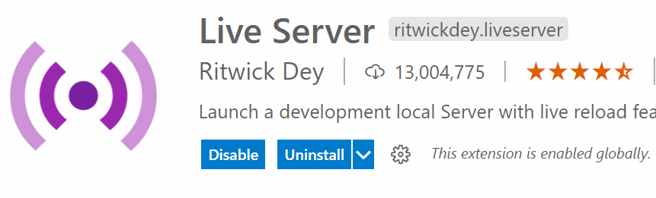
  + **Vscode-icons**

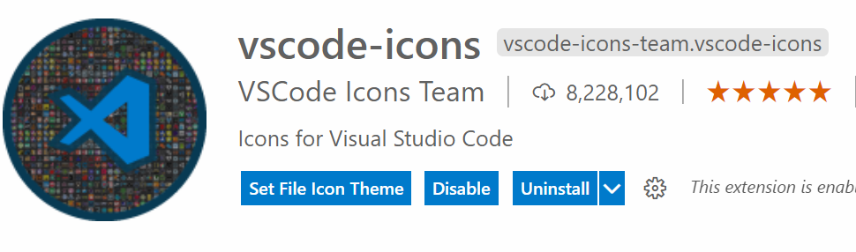

**What is Live Server / WebServer / HttpServer?**

* Webserver resembles both hardware and software
* It satisfies the client request by sending and receiving data.
* The popular webserver software
  + IIS [Internet Information Services Manager]
  + Tomcat [Apache]
  + Light TPD etc..

**Web Terminology**

* **Internet**
* **Web**
* **Web Server**
* **Web Site**
* **Web Application**
* **Web Page**
* **URL**
* **Protocol**
* **Blog**
* **Wiki**
* **Podcasting**
* **Widgets**
* **Web Debugger**
* **Web Browser**

**What is a Web Site?**

* Website is a **virtual** directory.